Sprint 2 Retrospective
  - Ako MSE800 | Sprint 2 | 19–23 October 2026 | Closed 24 October 2026

1. Sprint Overview
Sprint goal: Deliver core MVP functions covering role-based login, staff account management, learner records, manual attendance, class sessions, and lesson creation.
At Sprint closure, 3 of 6 associated stories were Done (50%). One story remained In Progress, one In Review, and one To Do. AKO-9 reached Done after Sprint closure.
Metric | Value | Basis
Stories | 6 | Associated with Sprint 2
Done | 3 | At Sprint closure
Completion rate | 50% | At Sprint closure
Incomplete | 3 | At Sprint closure

2. Story Status at Sprint Closure
Issue | User story | Owner | Closure status
AKO-8 | Log in by role | Leon | Done
AKO-9 | Manage staff accounts | Leon | In Progress
AKO-10 | Keep learner records | Pei | Done
AKO-11 | Manage class sessions | Shuohui Liu | To Do
AKO-12 | Record attendance by hand | Pei | Done
AKO-14 | Create a lesson | Sandhya | In Review

3. Statistical Findings
Figure 1 — Completion split: 3 Done and 3 incomplete stories (50% each).

Figure 2 — Cross-Sprint comparison: Sprint 1 100%, Sprint 2 50%, Sprint 3 12.5%. Only Sprint 2 represents a closed-Sprint result; Sprint 1 and 3 are active-Sprint snapshots and should not be compared as final outcomes.
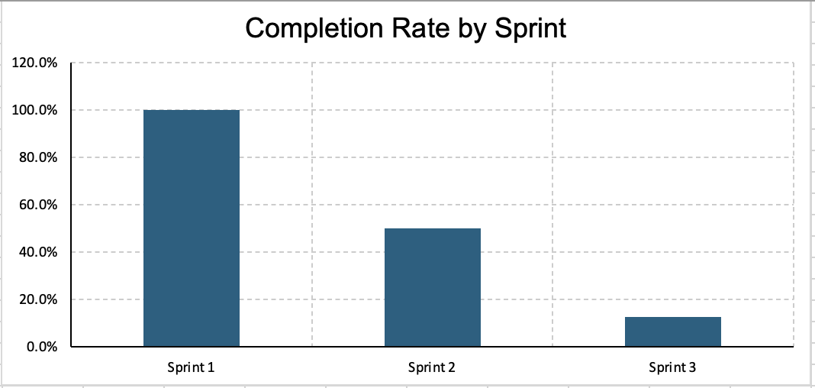
Figure 3 — Sprint 2 story ownership: Leon 2, Pei 2, Sandhya 1, Shuohui Liu 1.
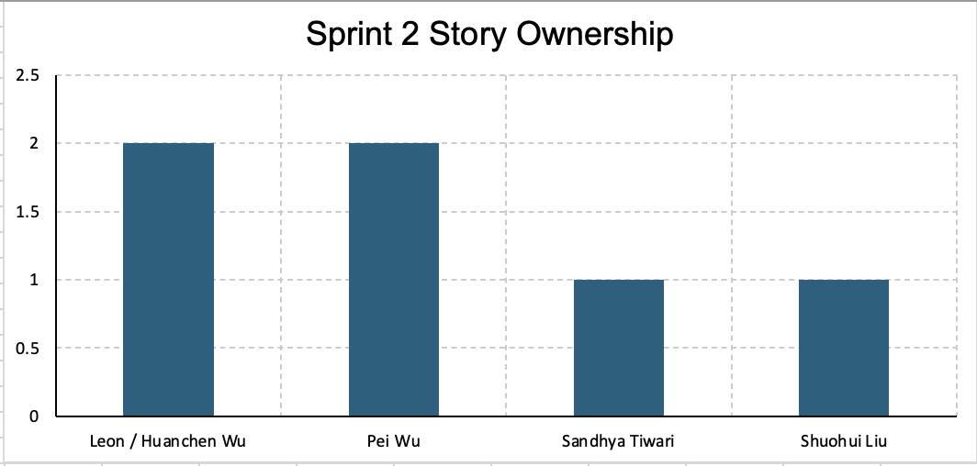
Figure 4 — Closure status: Done 3, In Progress 1, In Review 1, To Do 1.
The four editable charts are provided in the accompanying Excel workbook for insertion into Confluence.
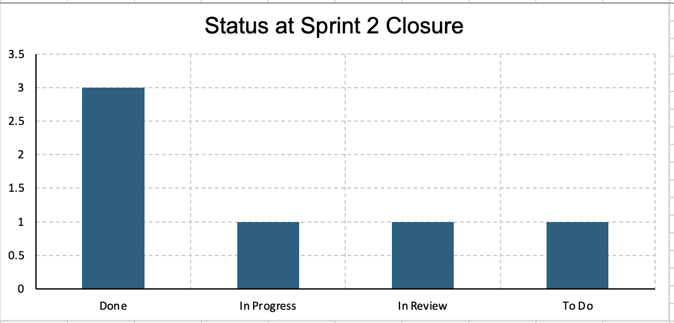

4. What Went Well
- Three core stories reached Done by closure: login, learner records, and manual attendance.
- Jira provided visible ownership and progress tracking.
- Stories and subtasks supported structured task management.

5. What Did Not Go Well
- Three of six stories were unfinished at closure.
- Some tasks required more technical investigation than expected.
- Reviews and development progress were not evenly distributed.

6. Lessons Learned
- Break stories into smaller subtasks with clear acceptance criteria.
- Identify technical dependencies before Sprint commitment.
- Begin review and integration testing earlier, and keep Jira statuses current.

7. Proposed Action Items
Action | Proposed owner
Reassess outstanding stories and Sprint priorities | Leon
Coordinate code integration and technical dependencies | Michael
Review acceptance criteria and testing readiness | Pei
Follow up on lesson creation and requirements | Sandhya

8. Next Sprint Improvements
Prioritise carry-over stories, improve estimates, surface blockers earlier, schedule regular code reviews, and verify task status before closing each Sprint.
Evidence note: Metrics are based on the user-provided Jira export. Retrospective observations and proposed actions should be validated by the team during the meeting.

